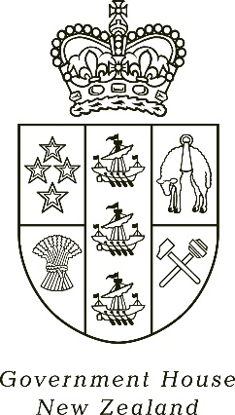

MEDIA STATEMENT
Governor-General Dame Cindy Kiro’s Statement on the death of Dame Cath Tizard, ONZ, GCMG, GCVO, DBE, QSO

31 October 2021
The Governor-General, The Rt Hon Dame Cindy Kiro and Dr Richard Davies were saddened by the news that Dame Cath Tizard has died.
“Dame Cath will always have a special place in our history as the first woman to be appointed as Governor-General. New Zealanders remember her fondly as someone who brought extraordinary energy and enthusiasm to the role. They appreciated her good humour and a forthright, unpretentious approach which enabled her to connect with people from all walks of life. We can thank her for blazing the trail for the women who followed her example and took their place in public life. “
Dame Cindy has extended sincere condolences directly to Dame Cath’s whānau and has expressed her wish to join them in honouring Dame Cath’s memory when circumstances allow.
Media Contact: Nerina Bennett, Government House Engagement and Communications, 021 470583, nerina.bennett@govthouse.govt.nz

