History of the house and gardens
In the 1870s when Mountain Road was only a bridle path, a young Mr Heather purchased a five acre (2 ha) property – now the front part of Auckland’s Government House grounds. When he married, he built a cottage, and is thought to have planted the Norfolk Pines at the east end of the Mappin Lawn by his front door. Later, he removed this cottage, and built a larger house where the present Government House stands. His father-in-law, Mr Brown, who was organist to Queen Victoria and Eton College, retired to New Zealand to live with the Heather family. Mr Brown designed and built a wood-panelled billiard room (the present formal dining room) and the rooms above it for himself.

With the help of his neighbours, Mr Firth and Mr Owen, Heather built the first rough road for carriages and pony carts. Both these neighbours have left their marks on the surrounding area. Firth built Firth’s Castle (more properly known as Clifton House) which still stands nearby, and planted the first trees on Mt Eden. Owen, after whom Owen’s Road is named, imported many rare trees and seeds which he persuaded his friends and neighbours to grow. Amongst others, he probably gave the Queensland kauri (Agathis robusta), and Morinda or West Himalayan spruce (Picea smithiana) to Heather for his grounds.

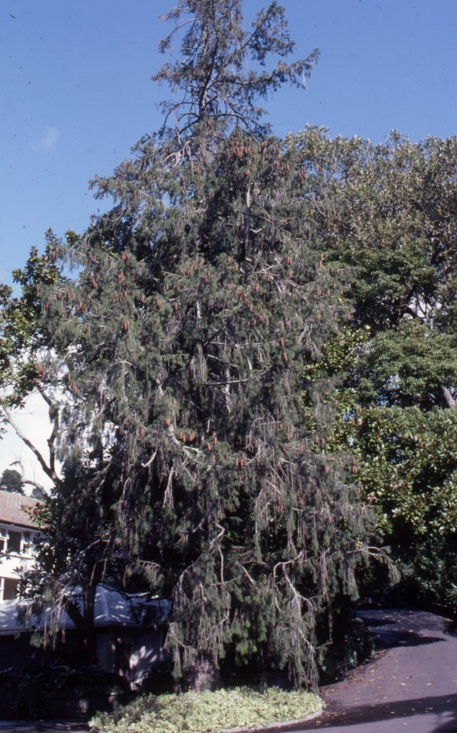
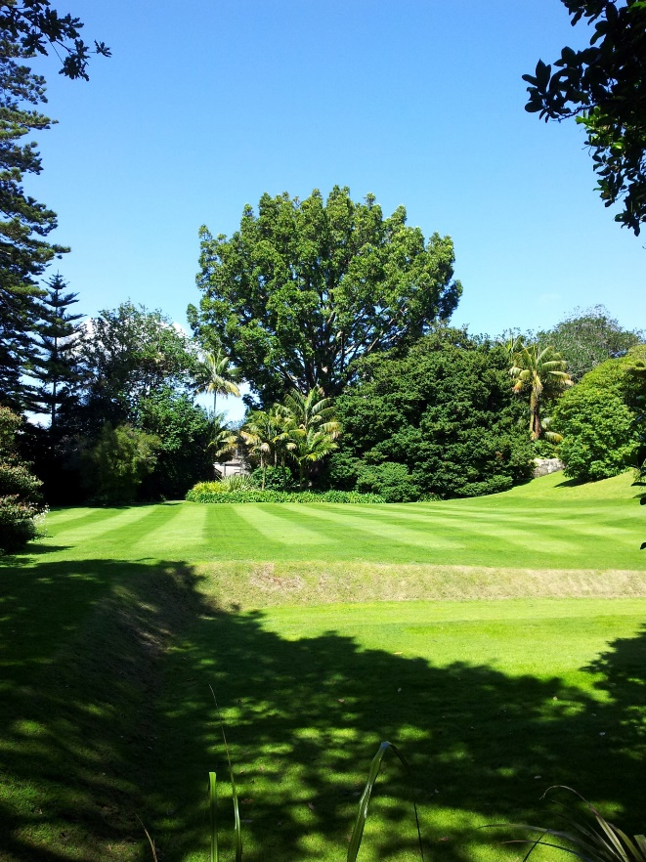
Queensland kauri, 2012 Morinda spruce, 1983

Heather sold the property to a Mr Brown Clayton, who called it ‘Boxley’. He and his wife collected antiques, and were noted for their beautiful delphiniums.

In 1921, Sir Frank Crossley Mappin bought the property and renamed it “Birchlands” after his home in England. Back in the 1920s there were few houses in the area, and the surrounding fields were bounded by rough stone walls.
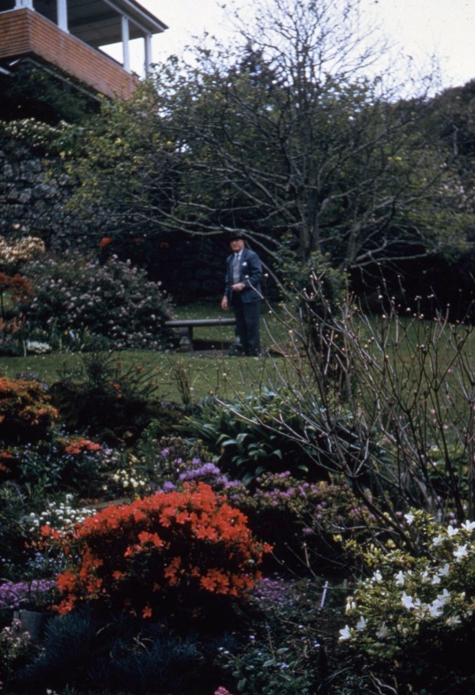
Sir Frank Crossley Mappin in the gardens, 1966

Life was leisurely, and bread, meat and milk were delivered to the back door of the house by horse-drawn carts. Mountain Road was still very narrow and rough, covered in loose metal, and with a steep dip by Almorah Road. Some years later, Sir Frank gave 20 feet (6m) of frontage to allow the road to be widened. Other residents followed suit, and the track which started as a bridle path became the present road.

Sir Frank and Lady Mappin were both keen horticulturists, and enjoyed the prospect of replanning the garden. But first, they pulled the old house down (except for the part built by Mr Brown, the organist) and built the present home.

Originally there was only a narrow path to the front door, and it was some years before the jumbled lava flows were excavated to make a drive. Other nearby great rocks, covered with ivy and bracken, were cleared to make a perfect natural rockery for plants collected from all parts of the world. This part of the garden was Lady Mappin’s special care. She read widely and imported many new plants. The rockery was particularly beautiful in spring.
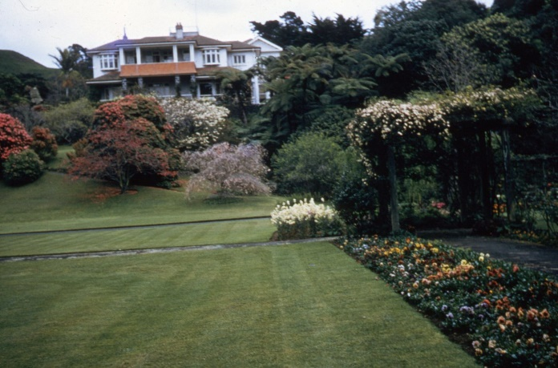
The house from the lower lawn, 1966
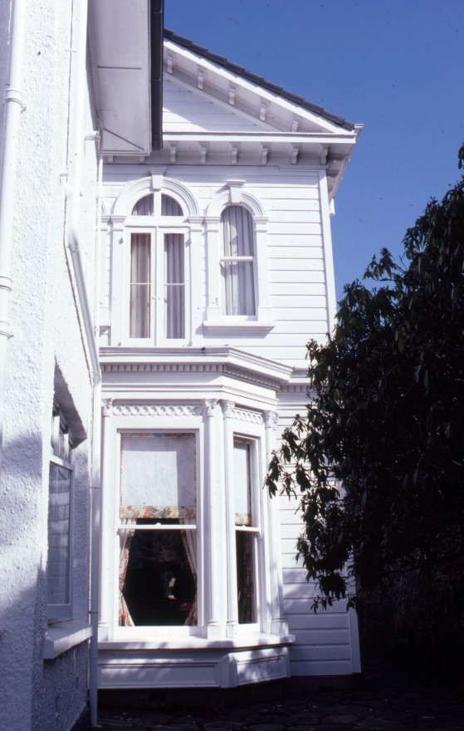
Wing built by Mr Brown, 1983

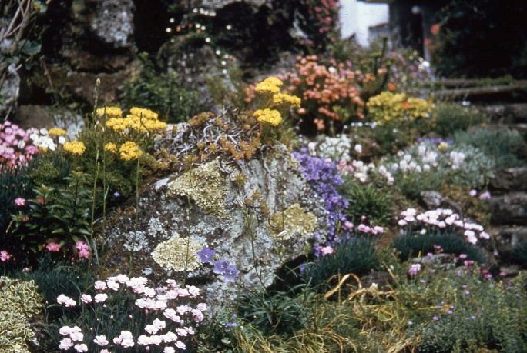
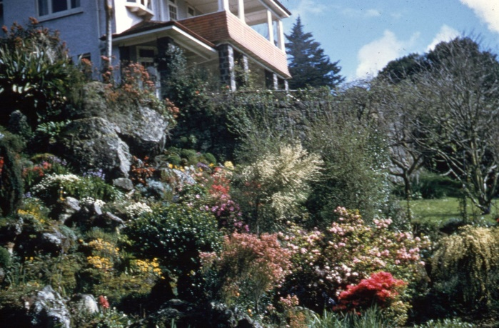

The rockery in spring, 1966 The rockery in spring, 1966
Tiny anemones and crocus from Greece, miniature iris, masses of little Cyclamen hederifolium (syn. C. neapolitanum), English snowdrops and primroses, rock phlox and pinks were scattered amongst very small rhododendrons and Kurume azaleas. In summer, the rockery was taken over by masses of starry-flowered Clematis flammula.

Sir Frank was keenly interested in orchids, and had an impressive glasshouse imported to house them. Later gardeners specialised in gloxinias and begonias.
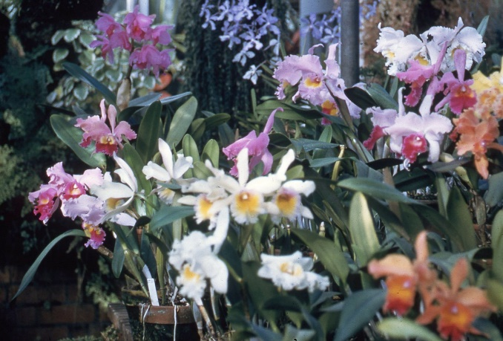
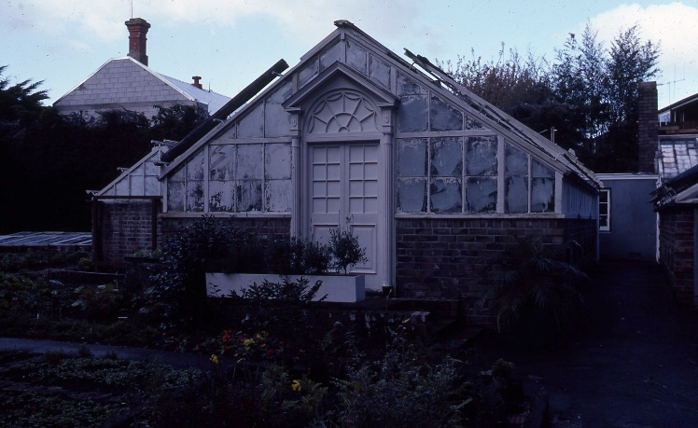

Orchids in glasshouse, 1966 Glasshouse, 1983

At the bottom of the garden, an old stone stable was removed to make way for a tennis court. The stone walls in the forest to the north of the tennis court are a remnant of the stables. Many kinds of trees and shrubs were planted, including magnolias, Prunus campanulata, cherries and a horse chestnut. In shaded rocky places under the trees, cinerarias and pale lavender Primula malacoides seeded themselves and became naturalised.

More formal flower beds were not forgotten, and the lawns were carefully levelled and tended. A dove-cote was built.
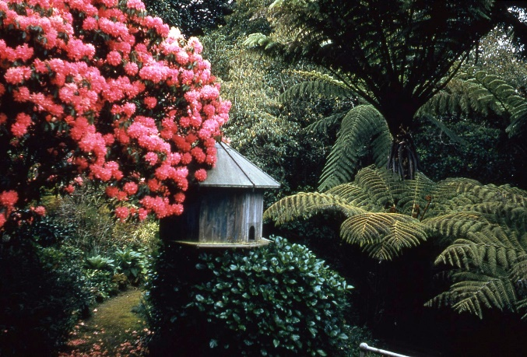
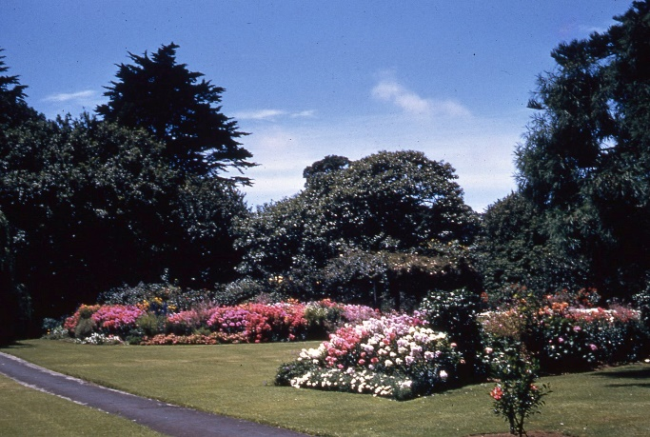
Formal beds on front (Mappin) lawn, 1966 Dovecot, 1966
Shortage of water in summer was always a great worry, so an artesian bore was put down 200 feet (61m) and pure water became available. The water was pumped to a reservoir above the house, providing invaluable irrigation when the city supply was not sufficient. The reservoir remained until the early 2000s. The pumphouse and pump are still used in summer to water the lawns.

In 1930, Sir Frank bought a further 6½ acres (2.6 ha) across the lane between Glenfell Place and Savannah Street which formed the northern boundary of the original property. This additional land had first belonged to Mr Patterson who planted many trees, including walnuts, a pear tree and a series of magnificent pohutukawas. The property was then bought by J J Craig, a cartage express company, and used as a field for the draught horses which pulled the drays of scoria from Craig’s quarry (now Eden Gardens). Following an event known in the Mappin family as ‘the second eruption of Mt Eden’, the quarry was closed down. Apparently J J Craig had a bit more to learn about the use of dynamite. A crack of thunder in the midst of afternoon tea one sunny day was followed by a hail of rocks and boulders, some of which came through the roof of the Mappin’s home.

During the Second World War, a massive vegetable garden was established on this new area (now the Governor’s Lawn) to provide for the wives and families of servicemen overseas. And in a long lava tunnel uncovered by the quarrying, priceless pounamu (greenstone) treasures from the Auckland War Memorial Museum were stored against bombing attacks. Even the plant type specimens from the herbarium went to the cave for safe-keeping.
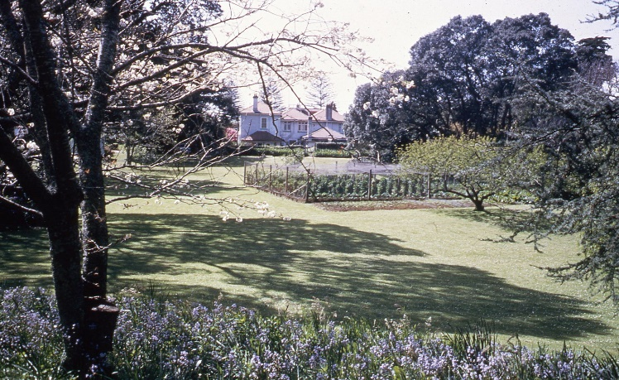
Rear lawn with vegetable garden, 1966

Having tamed the front part of the garden, Sir Frank and Lady Mappin turned their attentions to the new challenge behind their house. Willows and a blue Atlas cedar were planted with other exotic trees.
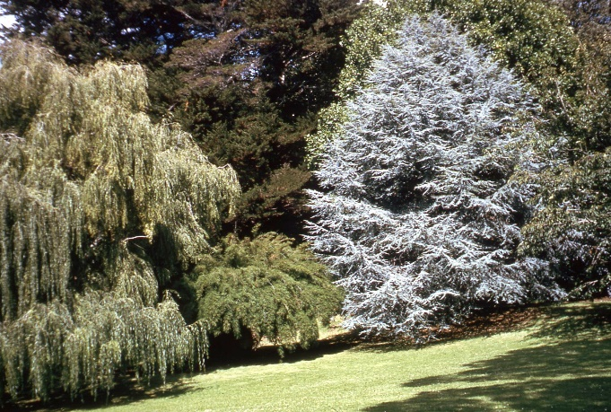
Weeping willow, Blue Atlas cedar, 1966

Edgar Stead of Ilam, Christchurch, famous for his rhododendrons and Ilam hybrid azaleas, suggested to Sir Frank that rhododendrons would do well in this new area. So many new varieties from abroad were introduced and carefully planted against the background of dark trees. Flowering cherries with an underplanting of bluebells, hyacinths and daffodils were added. Thus the garden became one of the wonders of Auckland in springtime. It was opened to gardening societies on one day each year, and occasionally used for garden parties and receptions.

From Mr Heather to the end of Sir Frank’s occupancy there were only three Head Gardeners who worked on the property for 48, 23 and 20 years each.

In 1962, Sir Frank and Lady Mappin decided to gift their home and land to Her Majesty the Queen, as the residence for her representatives to use whilst in Auckland. They retained a life-time interest in the property and the deed of gift was formalised byu the then New Zealand Prime Minister, Keith Holyoake, on behalf of the Queen, in 1963. On 19 December 1966, having spent 45 years creating the garden, Sir Frank and Lady Mappin informed the Prime Minister by telegram that they had vacated “Birchlands” and that the house was now empty and in the hands of the Government to prepare it for His Excellency the Governor-General. There began a whole new life for the house and gardens.

Preservation and development of the trees and garden
Sir Arthur Porritt, during his term as Governor-General (1967-1972), was concerned for the future of the trees on the property and caused the following clause to be inserted into the agreement by which the Crown took over the property from Sir Frank and Lady Mappin:

No work shall be put in hand which is likely to result in the cutting down or damage to any tree or shrub without the prior approval of any two of the following: Head Botanist, Auckland Museum
Director, Plant Diseases Division, DSIR
Head Gardener, “Birchlands”.

With the transfer of the property to the Crown, the Ministry of Works assumed responsibility for the maintenance of the house and grounds.

The house was altered to better suit its new purpose; a service wing was added to the back. Unfortunately, the grounds deteriorated rapidly – trees were cut out and the once proud rockery became neglected and overgrown.
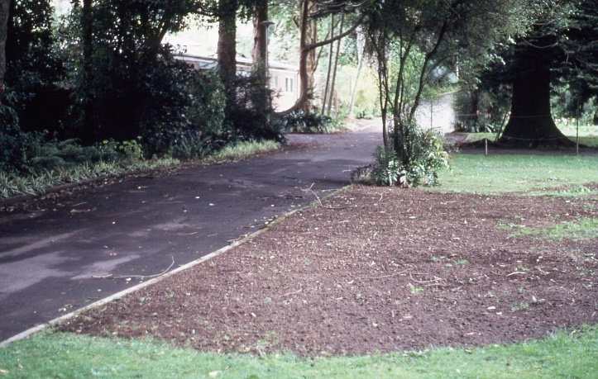
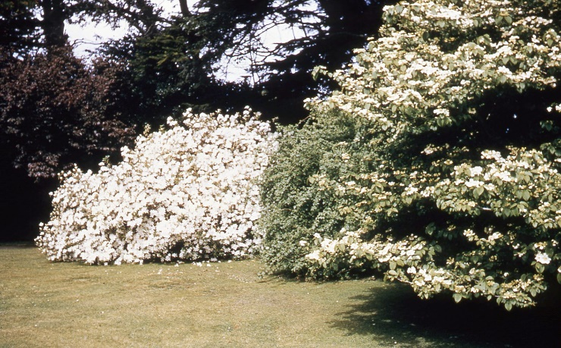
Spreading deciduous white azaleas, 1966 Bare ground after their removal, 1980

Along the main drive and elsewhere were large, old spreading shrubs of deciduous white azaleas – a picture in spring. When questioned about the removal of the nearly one hundred year old shrubs, Ministry of Works staff reported that they had seen no leaves for several months and presumed the plants dead.

Sir Frank’s family, who had maintained a keen interest in the property were understandably upset. Representatives travelled to Wellington to meet with the then (1977-1980) Governor-General, Sir Keith Holyoake. This, together with negative press publicity in Auckland, saw the revival of Sir Arthur Porritt’s vetting committee in 1980.

The Gardens Committee, augmented by household staff, have regularly met since. An early task was the preparation of a Gardens Management Plan to guide development. This includes a register of the historic and notable trees on the property. Another innovation has been the appointment of longer-term contractors to maintain the garden, ensuring that experience and expertise with the garden and its plants is built up, giving many of the advantages gained from the long-serving Head Gardeners and gardening staff prior to use as Government House.

All biological systems are dynamic, and no trees last forever. Thus, there is a programme for the gradual replacement of the ‘mainframe’ of trees as they become senescent or diseased. One of the major decisions of the Garden Committee in the 1990s was the removal of several over-mature macrocarpas (Cupressus macrocarpa) which lined the south-west boundary of the property with Mt Eden and Eden Gardens. Originally planted for quick-growing privacy and shelter for the specimen trees below, they had outgrown their usefulness – and were in fact shading and distorting the specimen trees.

Perhaps the most unique feature of the gardens in their central city setting are the two large expanses of lawns, ideally suited to garden parties and other events. The management plan recognises their importance, and the fact that surrounding tree and shrubbery growth, if unchecked, will encroach upon them. Maintaining the health and extent of the lawns is a key principle, including the lifting and subtle pruning of the magnificent clumps of hundred year old pohutukawa (Metrosideros excelsa) that grace the rear lawn.
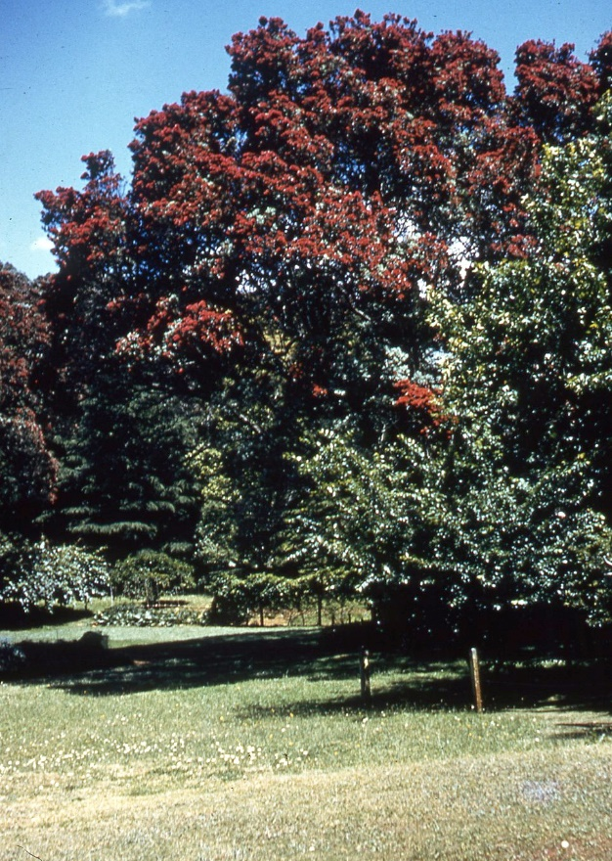
Pohutukawa on rear lawn, 1966

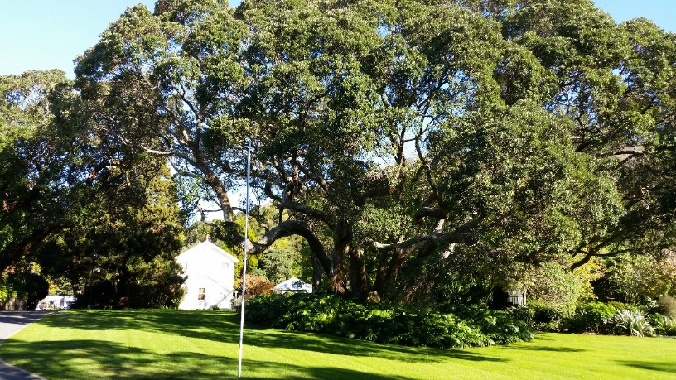
The largest Pohutukawa bordering rear lawn, 2014

Dame Catherine Tizard, Governor-General from 1990 to 1996, instigated the naming of the larger rear lawn where major vice-regal functions are held as the Governor’s Lawn, and the older, historic front lawn as the Mappin Lawn, in honour of Sir Frank and Lady Mappin’s gift.
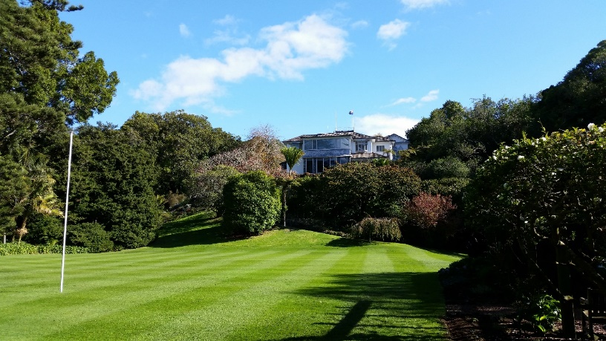
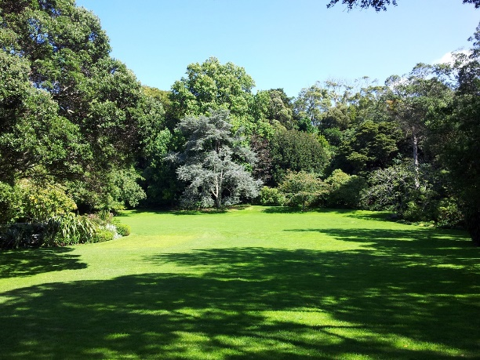
Governor’s Lawn, 2012 Mappin Lawn, 2014

In the ‘secret garden’ off the Mappin Lawn is a small stone bench in front of a reflecting pond. On the bench is a plaque which reads:

May this garden created by Sir Frank and Lady Mappin always be protected and cared for in memory of them.
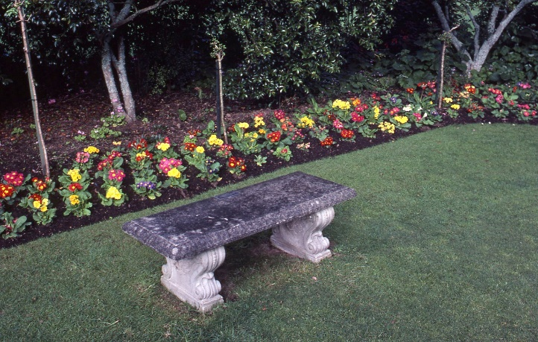
Stone bench in ‘secret garden’, 1983

Three Kings Islands connection
The Three Kings Islands lie 60 km north-east of Cape Reinga and are home to several dozen endemic (only naturally found there) species of plants and animals. The largest island, Manawa Tawhi (Great Island) is home to two endemic plants which, when discovered in the mid-twentieth century, had been reduced to single individuals. Tecomanthe speciosa is a robust liane with sprays of cream flowers and Pennantia baylisiana is a large-leaved cousin of kaikomako (P. corymbosa) of mainland forests.

Sir Frank Mappin, ever alert to botanical and horticultural novelties, retained close ties with both the Auckland War Memorial Museum and the DSIR, forerunner of today’s Crown Research Institutes. He followed the discovery of new endemic plants on the Three Kings with interest and grew them in his garden.

Today, several of these species grow in the plantings to the east of the tennis court: most notably Pennantia baylisiana and Elingamita johnsonii. Several large plants of Tecomanthe speciosa grow over the rock walls each side of the steps to the west of the tennis court up to the Mappin Lawn.

Compiled by Anthony Wright, Director of Canterbury Museum and a member of the Government House Auckland Gardens Advisory Committee since 1980, and formerly Curator of Botany at Auckland War Memorial Museum. Including excerpts from a valuable personal memoir by Lady Mappin held by the author.

