Engaging with the Governor-General

Of New Zealand

June 2019

Useful contacts and telephone numbers
Your engagement with the Governor-General is likely to involve contact with a number of our teams at Government House. Here are some key contact details.
Government House Reception | Ph.: 04 389 8055  Fax: 04 389 5536 | Email: ghinfo@govthouse.govt.nz
Addresses | Courier Address | Postal Address
 | Government House, ATTN: (name)  C/- Parliamentary Secure Delivery, Parliament Buildings, Wellington 6011 | Private Bag 39995, Wellington Mail Centre, Lower Hutt 5045
Engaging with the Governor-General | Email: diary.admin@govthouse.govt.nz
Governor-General website | For more information about the Governor-General and Government House, please visit: www.gg.govt.nz
Media enquiries | Email: ghinfo@govthouse.govt.nz

Contents

Contents 3

Introduction 4

The Governor-General of New Zealand 4

The Strategic Priorities of the Governor-General 5

Considerations surrounding the Governor-General 6

Inviting the Governor-General to attend your event 9

Asking the Governor-General to host an event at Government House 9

The Office of the Governor-General will process your invite/request 11

Event Coordination 12

Post event evaluation 12

Introduction
We want to help you make the most of your engagement with the Governor-General so have prepared some guidance for some of the most common ways of connecting with the Governor-General and with Government House.
This document will assist with:
- inviting the Governor-General to your event;
- requesting the Governor-General host your event at Government House;
- understanding the expectations and standard requirements for when the Governor-General is involved with your event;
- ensuring that there is consistency in the consideration of invitations and requests by the Office of the Governor-General; and
- protocols and best practices to consider and how they relate to engaging with the Governor-General.

These guidelines should be read in conjunction with the Governor-General’s website www.gg.govt.nz

The Governor-General of New Zealand
The Governor-General is a symbol of New Zealand’s unity and leadership, with the holder of the office fulfilling important constitutional, ceremonial, community, and international roles.

Her Majesty Queen Elizabeth II is New Zealand’s Head of State. The Governor-General is Her Majesty’s representative in New Zealand and is appointed on the recommendation of the Prime Minister of New Zealand.
New Zealand's Head of State is non-partisan and is not involved in the "business" of government, which is the responsibility of the Prime Minister and the Cabinet.

The Governor-General can be invited to attend or host events and visit organisations, charitable enterprises and schools.

We welcome invitations of all types and would particularly like to encourage people to think beyond ribbon cutting and opening new buildings. Some of the most satisfying events the Governor-General has been involved with have occurred when people have thought about engaging with Her Excellency in new and exciting ways.

Who is our current Governor-General?

Her Excellency the Right Honourable Dame Patsy Reddy was sworn-in as the 21st Governor-General of New Zealand on 28 September 2016. Dame Patsy's previous roles and experience is in law, business, and the public sector.

The Strategic Priorities of the Governor-General
Each Governor-General holds the position for five years. One of their first tasks is to develop a strategic plan for their term. Each Governor-General has different interests and they are encouraged to bring their own expertise and experience to bear as they formulate a vision and mission for their term.

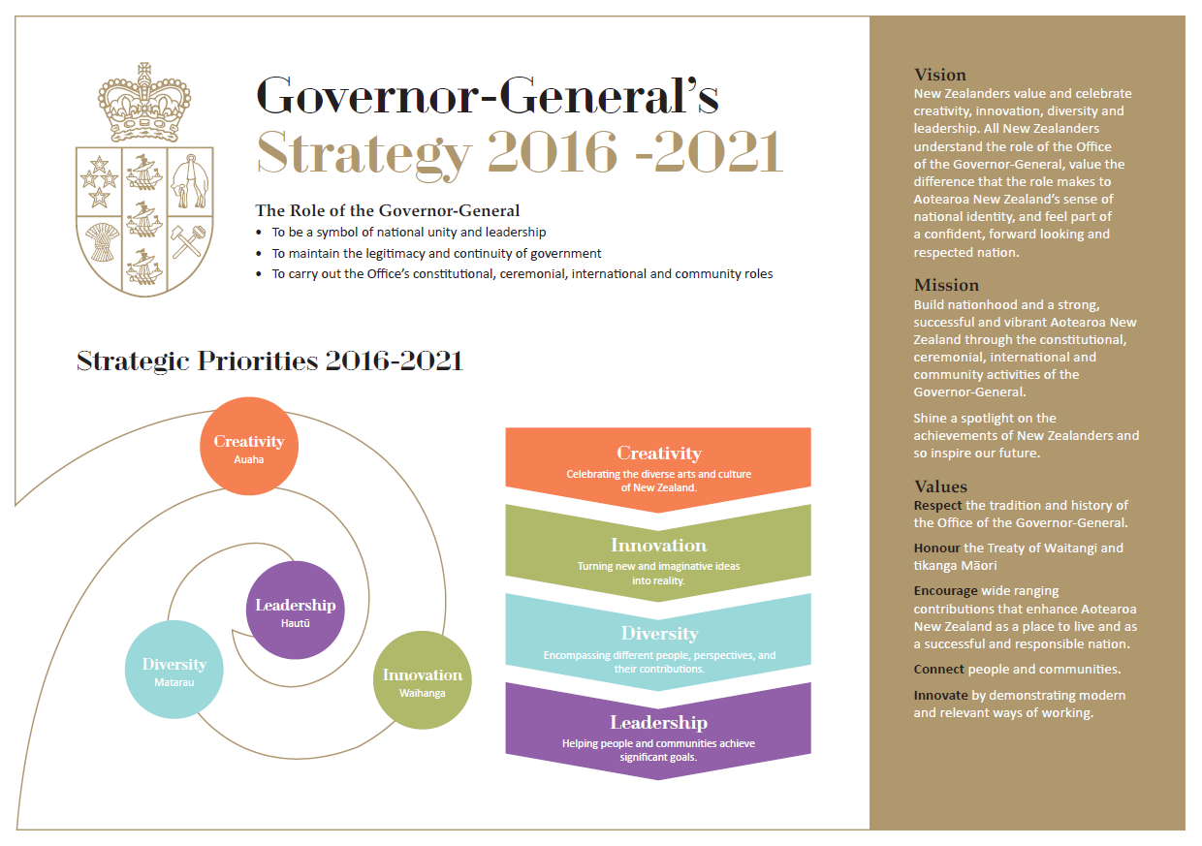Strategy on-a-page

Considerations surrounding the Governor-General
As the Governor-General is The Queen’s representative in New Zealand, there are special considerations and protocols to observe. Government House staff are available to work with you to help determine which apply and to make sure you are confident working within these guidelines.
This section details some of the key protocols that will help you determine how best to engage with the Governor-General.

Governor-General and Prime Minister at the same event

It is unusual for both the Governor-General and Prime Minister to attend at the same event. This usually only occurs for events of national significance such as ANZAC Day or the opening of Parliament. While you may wish to invite both to your event, further consideration will be required if the Prime Minister is invited or confirmed to attend.

Speech by the Governor-General

If the Governor-General is hosting your event at Government House Wellington or Government House Auckland, she will deliver a speech.

There is no requirement for the Governor-General to speak if she is attending an event elsewhere. If a speech is required, please indicate this on the invitation form. The Governor-General’s speeches are typically 3-5 minutes long. The Governor-General does not give keynote speeches.

Housekeeping announcements should be made before the Governor-General arrives and we request that any introduction be kept simple. We suggest:
Please welcome Her Excellency the Right Honourable Dame Patsy Reddy, Governor-General of New Zealand.

When the Governor-General hosts an event at Government House, she is the first speaker, and will be introduced by her Aide-de-camp. If you are using an MC for your event, they will take over once the Governor-General finished speaking.

Cultural considerations

The Governor-General enjoys engaging with all New Zealanders and to help her be prepared we like to ensure we are aware of all cultural practices and protocols surrounding an event. We encourage you to share as much information as you can, particularly if you would like the Governor-General to perform or engage in a cultural exchange e.g. powhiri, receiving of a lei, fist and palm salute etc.

When the Governor-General is hosting an event at Government House our own cultural protocols apply. We are more than happy to discuss incorporating other elements alongside these, so please include this on your request form.

Media and Social Media

Media are welcome to attend events at Government House but there are strict protocols around behaviour in the house and access to guests. A member of our communications team must accompany visiting media at all times.

Organisations working with us are welcome to send out media advisories before their event but these need to be approved by us in advance. We do not send out media releases on behalf of other organisations.

The Governor-General is active on social media and we are happy for you to share our social media posts on your own feeds. Please get in touch with the Government House communications team to discuss any queries or concerns you may have

Security

We encourage you to think about the security aspects of your event. This means thinking about any potential issues or barriers that may result in the Governor-General or your guests being at risk. For example:
When attending your event | When at Government House
Is it a public event, or will all guests receive an invitation?  What numbers are you expecting?  Will any other VIPs or official dignitaries be invited?  Will alcohol be served?  Is it an indoor or outdoor venue?  What are the wet weather contingencies?  Has there been any media coverage or publicity of the event in advance?  Will the event or people attending attract protest or controversy?  Is the event location owned by the organisers/agency, rented or co-located?  Do you have a Health and Safety plan? | Has there been any media coverage or publicity of the event in advance?  Will the event attract protest or controversy?  Who is being invited?

If you identify any actual or potential security risks, it does not necessarily mean we will decline your invite/request. It will however assist us with the decision-making process, and if it were to be accepted, it will help us in mitigating any risks. We encourage you to contact us if you have any questions.

Dress

Here is a guide to dress code options for use on the invitation form:
Dress | Translation | Description
Black tie | The most formal of our events, taking place in the evening. An opportunity for the most glamorous attire. It may also be described as ‘dinner jackets’, ‘dress for dinner’ or ‘tuxedos’. | Traditional dinner jacket, trousers, shirt and bow tie.  Long gowns or skirts, or evening trousers.
Evening wear | A common dress code for evening functions. Also known as cocktail wear. This is still at the formal end of the spectrum, but can be more creative and relaxed than black tie. | Business suit with shirt and tie.  Cocktail dress, or similar smart dress, skirt or evening trousers.
Business wear | Your best office wear. Often applies for daytime or evening events where most guests will be coming directly from work. | Business suit with shirt, with a tie.  Smart day dress, trouser suit, skirt and jacket.
Day wear | The Government House version of smart casual, this is a tidy but less formal option. We usually describe this as what you would wear to a wedding or church. | Tidy shirt and trousers, jacket, blazer, or sweater.  Day dress, skirt or trousers, cardigan or more informal jacket.  Avoid denim, shorts, sportswear, and jandals.

Travel and Accomodation
We will take responsibility for the Governor-General’s accommodation, security and transport arrangements. Government House does not cover the costs of travel or accommodation for clients, guests, speakers, performers etc.

Inviting the Governor-General to attend your event

The Governor-General attends a wide range of events and engagements around New Zealand. These events include:
- Patronage events,
- award ceremonies, symposiums, celebrations, openings, launches and anniversaries,
- visit to organisations, businesses, charities, schools, and tertiary institutions that are making a positive impact in their communities and the country, and
- special community gatherings and events, particularly those that celebrate different aspects of New Zealand life and culture.

Asking the Governor-General to host an event at Government House

The Governor-General hosts a wide range of events at Government House Wellington and Government House Auckland. You may wish to discuss an idea for an event with Government House before submitting a request. This does not constitute acceptance of your engagement, which will be considered once you have submit your invite/request in writing.

Some of the more common events are:
- Reception – a standing event with a small number of speeches and a focus on mixing and mingling. Drinks and canapés are usually served.
- Lunch – a seated meal, usually for a smaller group and more intimate discussion.
- Dinner – a seated evening meal. A more formal occasion with speeches. May include performances or award presentations.
- Morning or afternoon tea – ideal for informal gatherings, which may be in conjunction with a forum, Q&A session, workshops, a small awards ceremony or other presentation.
- Award presentation – a seated award ceremony followed by a reception, morning or afternoon tea.
- Forums i.e. workshops, symposium, Q&A session, and other forms of collaborative and substantive engagement between guests and the Governor-General.
- Performances of music, dance and drama.

Protocols for Government House events
The Governor-General is the Queen’s Representative in New Zealand, and Government House is the Governor-General’s private residence.

- Events at Government House are invitation only. Invitations are not transferable.
- Government House does not operate as a venue for events where the Governor-General is not present.
- Organisations are not able to sell tickets to attend an event at Government House, or otherwise seek payment from guests to attend.
- Any fundraising at the event will need to be discussed and agreed to in advance.
- People will not be admitted if they are not on the approved guest list.
- All members of your organisation who will be helping to run the event will need to go through a police vetting process.
- Health and Safety briefings will be provided to all members of your organisation helping to run the event and to guests before the formalities of the event begin.

Food and Beverage
Government House caters for all events hosted by the Governor-General at Government House and can accommodate a wide range of dietary needs.
Government House is proud to promote quality New Zealand produce.
Government House provides all food and beverages for events hosted at the house. Our Head Chef holds sole discretion for the final menu to ensure it aligns with Government House policies, New Zealand food safety standards and the Food Act 2014. We may serve alcohol at events (on request) however, not to guests under 18 year old. You will need to inform us if young people are attending to ensure they can be catered for appropriately.

Costs
Our coordinators will discuss with you how the costs will be shared for your event. If the scope or cost of the event changes during the planning process, we will continue to talk with you about how those additional costs will be met.

Governor-General programme changes

The Governor-General’s programme is constantly changing to balance the requirements of the role and unexpected events at a national and international level. Please note that unexpected programme changes may oblige us to cancel or postpone your event or to have someone other than the Governor-General host your event. Where this happens, we will endeavour to provide as much notice as possible.

When the Governor-General is overseas, or otherwise unable to perform her duties, the Administrator of the Government is able to excise all the powers and undertake all the duties of the Governor-General. From time to time, the Administrator may step in to host events at Government House. First in line of succession is the Chief Justice, followed by the next most senior member of the New Zealand judiciary.

The Office of the Governor-General will process your invite/request

What we will be doing
The Office of the Governor-General meets regularly to consider all the new invitations and requests received since the previous meeting. Once an initial decision recommendation is reached, we meet with the Governor-General who will endorse or decline our recommendation. On occasion, the Governor-General will ask for more information to assist her decision.

This process can take several weeks.

What we consider when reviewing invites/requests

The Governor-General receives many invitations each year. Each request is discussed but not every request can be accepted. We understand that this is disappointing, but often the deciding factors are logistical or timing issues, not the substance of the invitation.

To assist our considerations, you may wish to include in your application information about:
- Whether the event is apolitical and appropriate for the participation of the Governor-General;
- Whether the event has a clear purpose and aligns strongly with the Governor-General’s strategy;
- Whether your organisation has the Governor-General as Patron, or has another existing relationship with Government House;
- Whether the proposed engagement contributes to the wide range of factors that enhance Aotearoa New Zealand as a strong, successful and vibrant nation.

Possible outcomes

During our process of consideration, there may be times when our coordinator contacts you for more information.

Typically, the decisions are clear:
- Accepted: the Governor-General has agreed to your proposal. We look forward to working with you.
- Declined: regretfully the Governor-General is unable to attend/host your event on this occasion.
- Discussion of an alternative option: on occasion, we may want to discuss a different date or different type of event.
- Held: the Governor-General is unable to attend or host your event on this occasion, but we would like to keep your contact details and information, to be in touch when future opportunities arise.

If your event is more than 6 months away it may be “held” for further consideration closer to time. You will be advised if this is the case.

Event Coordination
If the Governor-General agrees to attend or host your event, you will receive an email from the Diary Coordinator confirming your event details – date, time, and location. In this confirmation notice, you will be introduced to the staff member from Government House who will work with you to ensure the Governor-General’s involvement in your event is seamless and beneficial for everyone.

Your invitation is accepted based on the date, timings and event description that you have provided in your application. Please ensure you alert us as soon as possible of any proposed changes to the timing or nature of the event, so that we can check that the Governor-General’s attendance is still possible.

Government House staff will advise you of the steps from here. There is information that we will need you to provide, such as:

- Run sheets for your event
- Guest lists
- Seating plans
- On the day logistics
- Assistance requirements i.e. mobility, dietary
- Infrastructure requirements
- Any proposed changes to what you initially submitted

It is important we receive this information on time, as it may affect the Governor-General’s ability to attend/host. You will be advised of our planning timelines at the beginning of the planning process.

Post event evaluation

Feedback

Feedback is an indicator for businesses, and we are keen to know whether our service and your experience engaging with the Governor-General is doing well or exceeding expectations. As such, we are always open to receive all types of feedback and encourage you to let us know yours after your event.

There are several channels you can provide feedback:
- General or informal feedback – phone, email, meeting with us in person
- Direct feedback - Customer Experience Survey (anonymous).

We are excited you are considering engaging with the Governor-General and look forward to hearing about your plans and how the Governor-General might support you/your organisation.

